CREATE TABLE Customers (
CustomerID INT PRIMARY KEY,
Name VARCHAR(50),
City VARCHAR(50),
Age INT
);
-- Orders table
CREATE TABLE Orders (
OrderID INT PRIMARY KEY,
CustomerID INT,
OrderDate DATE,
Amount DECIMAL(10,2),
FOREIGN KEY (CustomerID) REFERENCES Customers(CustomerID)
);
-- Products table
CREATE TABLE Products (
ProductID INT PRIMARY KEY,
ProductName VARCHAR(50),
Price DECIMAL(10,2)
);

-- OrderDetails table
CREATE TABLE OrderDetails (
OrderDetailID INT PRIMARY KEY,
OrderID INT,
ProductID INT,
Quantity INT,
FOREIGN KEY (OrderID) REFERENCES Orders(OrderID),
FOREIGN KEY (ProductID) REFERENCES Products(ProductID)
);

-- Customers
INSERT INTO Customers VALUES
(1, 'Alice', 'New York', 30),
(2, 'Bob', 'Los Angeles', 45),
(3, 'Charlie', 'Chicago', 25),
(4, 'Diana', 'New York', 35);

-- Products
INSERT INTO Products VALUES
(1, 'Laptop', 1200.00),
(2, 'Smartphone', 800.00),
(3, 'Tablet', 300.00),
(4, 'Headphones', 150.00);

-- Orders
INSERT INTO Orders VALUES
(1, 1, '2024-01-10', 1500.00),
(2, 2, '2024-02-15', 2000.00),
(3, 3, '2024-03-05', 600.00),
(4, 4, '2024-01-20', 300.00);

-- OrderDetails
INSERT INTO OrderDetails VALUES
(1, 1, 1, 1),
(2, 1, 4, 2),
(3, 2, 2, 2),
(4, 2, 3, 1),
(5, 3, 3, 2),
(6, 4, 4, 2);

SELECT* from Customers
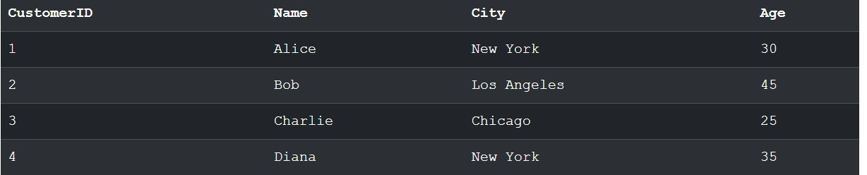
SELECT* from Products
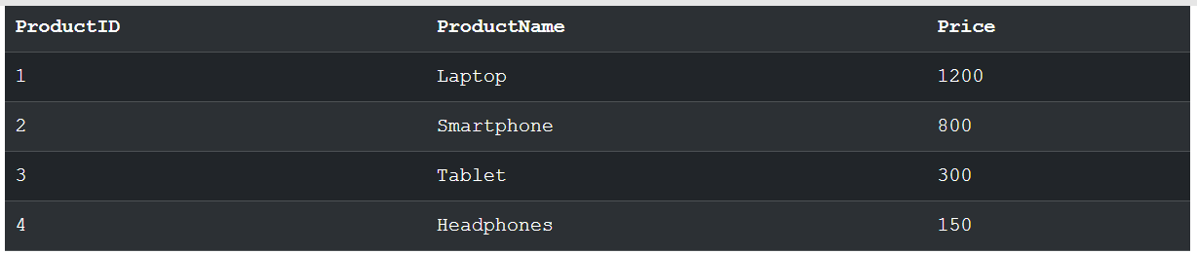
SELECT* from Orders
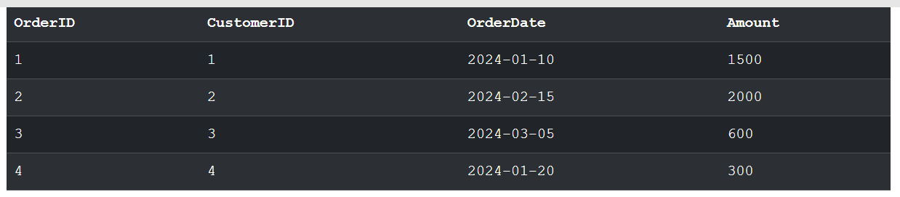
SELECT* from OrderDetails
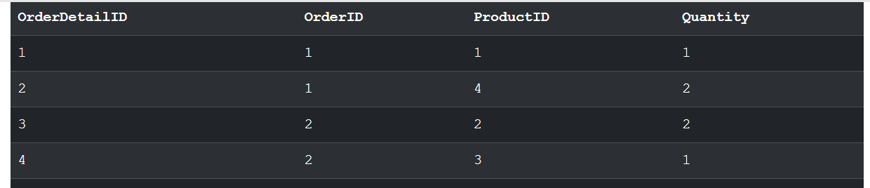

-- Select all customers from New York ordered by age
SELECT * FROM Customers WHERE City='New York' ORDER BY Age;

-- Count number of orders per customer
SELECT CustomerID, COUNT(*) AS OrderCount
FROM Orders
GROUP BY CustomerID;
-- INNER JOIN: Orders with Customer info
SELECT o.OrderID, c.Name, o.OrderDate
FROM Orders o
INNER JOIN Customers c ON o.CustomerID = c.CustomerID;
-- LEFT JOIN: All customers with their orders (if any)
SELECT c.Name, o.OrderID
FROM Customers c
LEFT JOIN Orders o ON c.CustomerID = o.CustomerID;
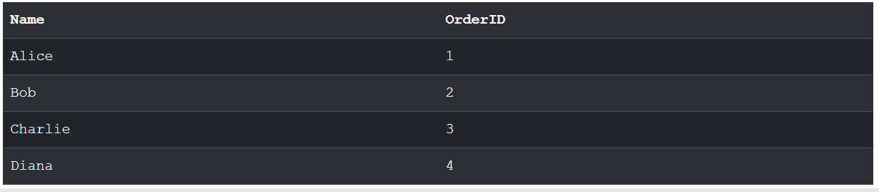
-- All orders with customer info
SELECT o.OrderID, c.Name
FROM Orders o
LEFT JOIN Customers c ON o.CustomerID = c.CustomerID;
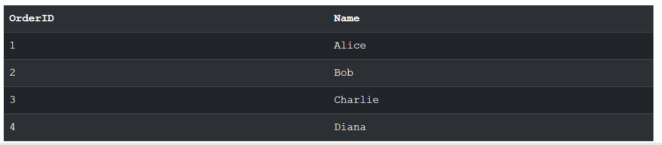
-- Find customers who have placed orders exceeding $1000
SELECT Name FROM Customers WHERE CustomerID IN (
SELECT CustomerID FROM Orders WHERE Amount > 1000
);
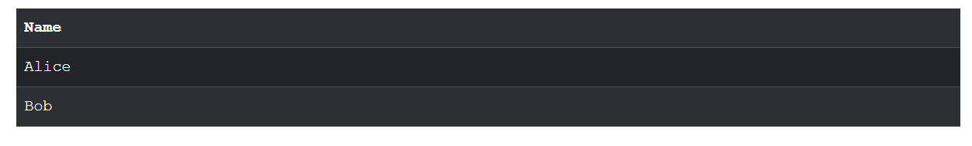
-- Get the most expensive product
SELECT ProductName FROM Products WHERE Price = (
SELECT MAX(Price) FROM Products
);
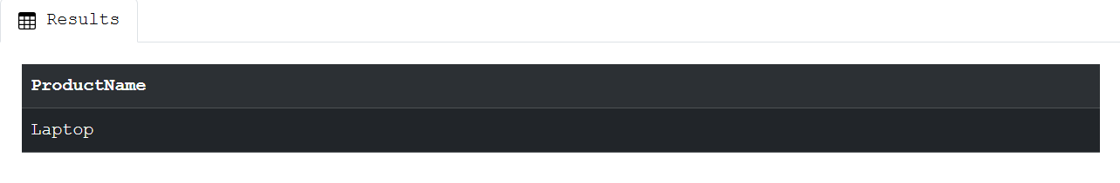
-- Total sales
SELECT SUM(Amount) AS TotalSales FROM Orders;
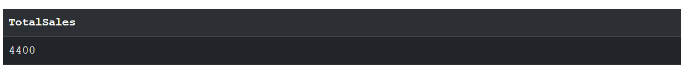
-- Average order amount
SELECT AVG(Amount) AS AvgOrderAmount FROM Orders;
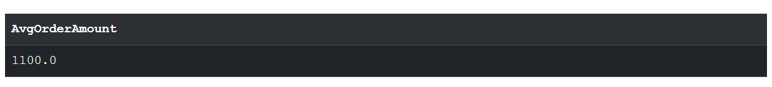
-- Total quantity sold per product
SELECT p.ProductName, SUM(od.Quantity) AS TotalQuantity
FROM OrderDetails od
JOIN Products p ON od.ProductID = p.ProductID
GROUP BY p.ProductName;
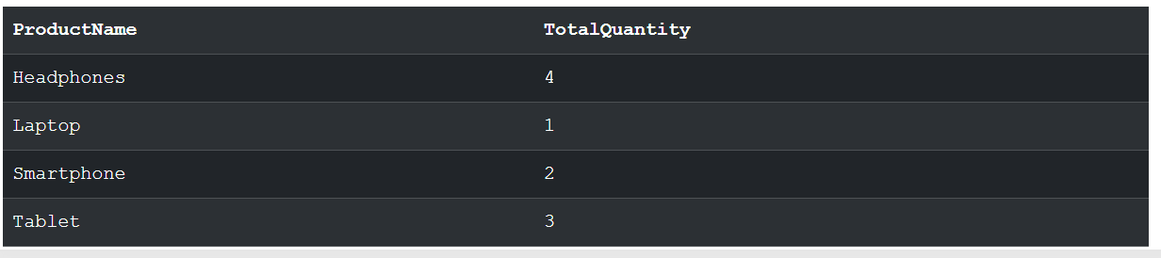
-- View: Customer order summary
CREATE VIEW CustomerOrderSummary AS
SELECT c.CustomerID, c.Name, COUNT(o.OrderID) AS NumberOfOrders, SUM(o.Amount) AS TotalSpent
FROM Customers c
LEFT JOIN Orders o ON c.CustomerID = o.CustomerID
GROUP BY c.CustomerID, c.Name;
-- Query from view
SELECT * FROM CustomerOrderSummary;
